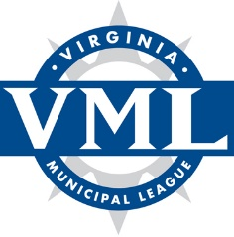

VML Transportation Policy Committee Meeting
Wednesday, July 28, 2021
9:00 – 11:30 a.m.
Via Zoom

Agenda

Welcome and introductions – Cindy Mester, Chair

Review 2021 General Assembly actions affecting Transportation policy/legislative items – VML staff

Briefings and issue discussion:

- The state of transportation revenues and funding – Deputy Secretary of Transportation Nick Donohue
- Update from the Department of Rail and Public Transportation – Jennifer Mitchell, Director of DRPT
- NVTA Transportation Technology Strategic Plan – NVTA Staff

Review of Transportation Policy Statement and proposed amendments – Committee and staff

Discussion of proposed positions to forward to VML Legislative Committee – Committee and staff

Final comments and adjournment

Chair: Cindy Mester, Deputy City Manager, City of Falls Church
Vice Chair: Accepting Nominations
Staff: Mitchell Smiley, VML

