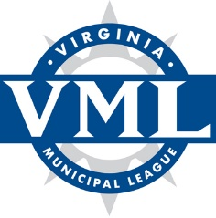
Human Development & Education Policy Committee
Friday, July 30, 2021
9:00 – 11:30 a.m.
Via Zoom
Proposed agenda

A. Call to order and welcome: Terry Short, Chair; City of Waynesboro Council Member

B. Issue discussions and updates:

1. Jail funding and usage issues (William H. “Bill” Hefty; Hefty Wiley & Gore, Richmond)

2. VDH funding adequacy study update (staff)

3. Marcus Alert update (staff)

4. Mental health parity potential policy position (staff)

5. Mental health services for community colleges (VCCS request) (staff)

6. School modernization study and ARPA funding update (staff)

C. Policy statement discussion (Committee members and staff)

D. Potential legislative positions to forward to VML Legislative Committee (Committee and staff)

E. Closing comments and adjournment

Chair: Terry Short, Council Member, City of Waynesboro

Staff: Jessica Ackerman (jackerman@vml.org); Janet Areson (jareson@vml.org)

