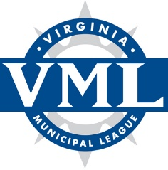

VML Finance Policy Committee Meeting
Thursday, July 29, 2021
9:00 – 11:30 a.m.
Via Zoom

Proposed Agenda

Welcome and introductions - Joshua Farrar, Chair

Review 2021 General Assembly actions affecting Finance policy/legislative items – VML staff

Briefings and issue discussion:

1. State funding overview, ARPA funding– Jim Regimbal, Principal, Fiscal Analytics

2. Strengthening the local tax base – Jim Regimbal, Principal, Fiscal Analytics

3a. School modernization commission issues and update – Jessica Ackerman, VML Policy & Advisory Relations Manager

3b. Statewide local option sales tax add-on for school construction/modernization – David Blount, Deputy Director, Thomas Jefferson PDC

Review of Finance Policy Statement and proposed amendments – Committee and staff

Discussion of proposed positions to forward to VML Legislative Committee – Committee and staff

Final comments and adjournment

Chair: Joshua Farrar, Town Manager, Town of Ashland
Vice Chair: Kevin Greenlief, Deputy Finance Director, City of Alexandria
Staff: Jim Regimbal, Principal, Fiscal Analytics (VML Consultant); Jessica Ackerman, VML

