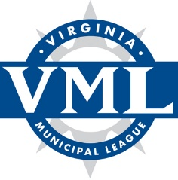

VML Environmental Quality Policy Committee Meeting
Thursday, July 29, 2021
1:00 – 3:30 p.m.
Via Zoom

Agenda

Welcome and introductions – Christopher Blakeman, Chair

Review 2021 General Assembly actions affecting Environmental Quality policy/legislative items – VML staff

Briefings and issue discussion:

- Gas recapture systems and wastewater facilities – Robin Lanier, Director of Renewable Gas, Southern Company Gas
- Overview of the current State and Federal policy environment – Preston Bryant

Review of Environmental Quality Policy Statement and proposed amendments – Committee and staff

Discussion of proposed positions to forward to VML Legislative Committee – Committee and staff

Final comments and adjournment

Chair: Christopher Blakeman, Environmental Manager, City of Roanoke
Staff: Mitchell Smiley, VML, Preston Bryant, McGuire Woods Consulting

